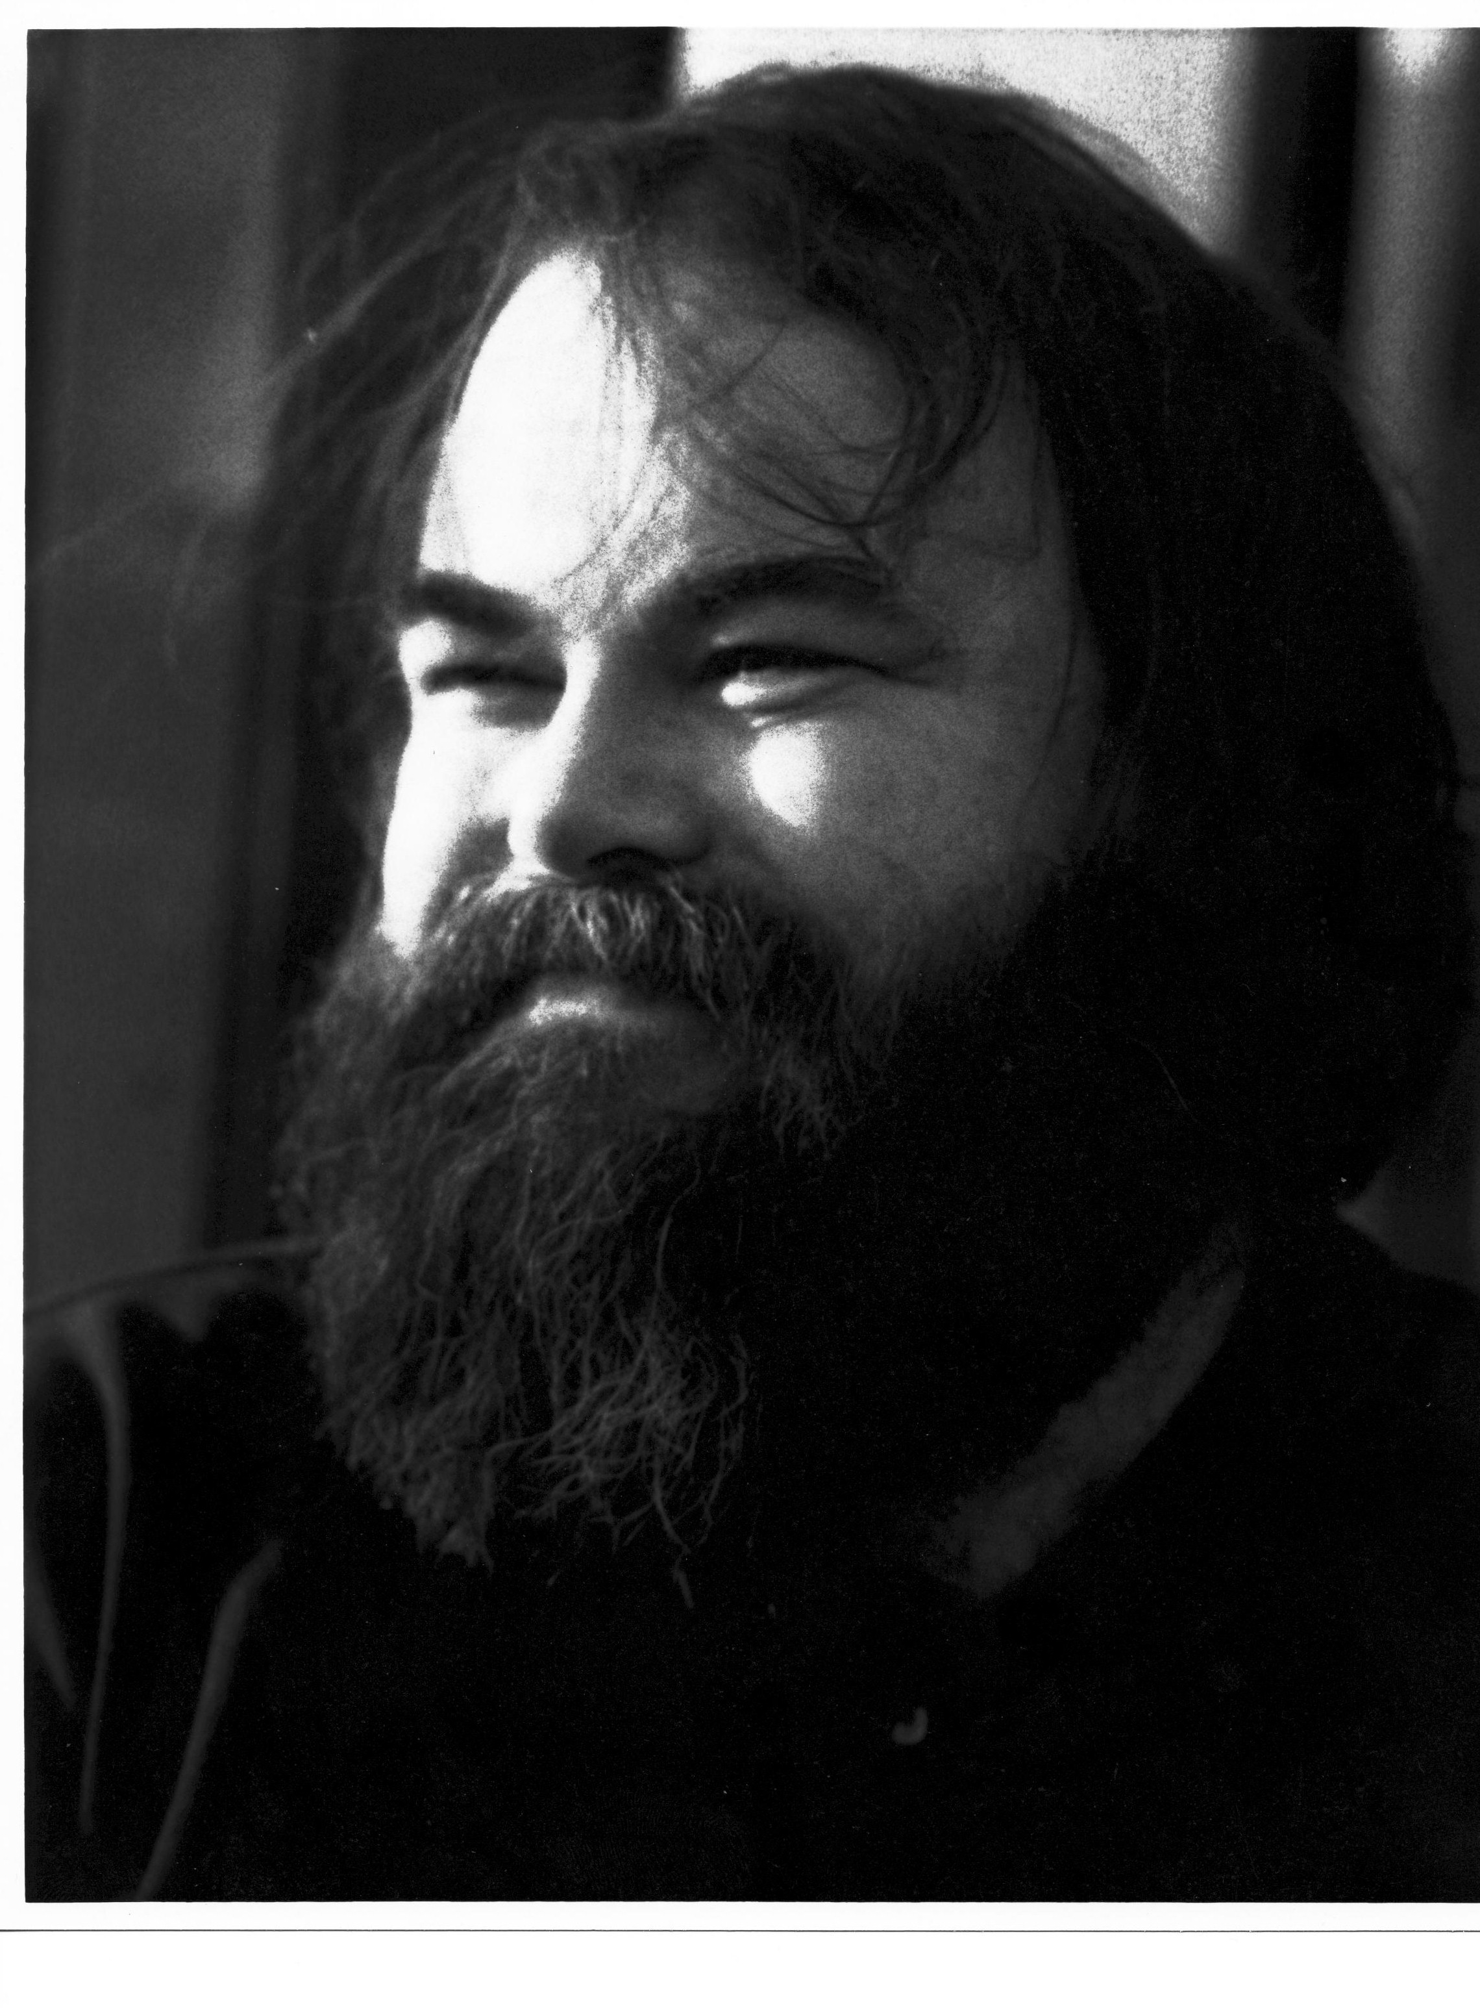

Title:
Plenty Good Room: The Theoretical and Therapeutic Contributions of Margaret Morgan Lawrence-- Pioneer African American Psychoanalyst, Psychiatrist, and Pediatrician

Abstract:

Pioneer psychiatrist and psychoanalyst Margaret Morgan Lawrence, M.D. was the first African American psychoanalyst trained in the United States, the first African American female pediatrician certified by the American Board of Pediatricians, and the first African American resident at the New York Psychiatric Institute. Drawing from Dr. Barbre’s twenty years of work with Dr. Lawrence, this presentation we will explore the impact of historical and cultural forces on Dr. Lawrence’s theoretical innovations and therapeutic contributions to the many clinical worlds of psychology, psychoanalysis, education, pastoral care, and medicine. Born in New York City in 1914, Dr. Lawrence was raised mainly in Mount Bayou and Vicksburg, Mississippi—the daughter of a teacher and an Episcopal minster. Her decision to study medicine came early, inspired by a passion for healing and by her family’s loss of a child, and her father’s pastoral ministry. A graduate of Cornell University, she received her medical degree from Columbia College of Physicians and Surgeons in 1940. She trained in psychoanalysis at Columbia Psychoanalytic Institute. Dr. Lawrence taught pediatrics and public health in Rockland County, and Harlem Hospital for many years, and the Child Development Center of Rockland County was renamed the Margaret Morgan Lawrence Center in 1989. In her writings Dr. Lawrence has pioneered the clinical teamwork approach in school settings, helping children and families of all backgrounds find strength and voice in the midst of personal struggle. Her play therapy innovations and methods in working with traumatized children are still taught today, and have inspired many generations of clinicians and civic leaders, while also continuing to influence groundbreaking changes in the way we think of community and individual medical and psychological care. In this presentation we will provide case examples from her clinical work, and also explore her theoretical contributions to the healing professions.

Prefers Not To Record The Lecture: No Recording

Leaning Objectives

- In this presentation we explore the biography of Margaret Morgan Lawrence, M.D., and the psychosocial influences on her vocational calling to the healing professions.
- In this presentation we will outline and describe the theoretical and therapeutic contributions of Dr. Lawrence’s clinical approaches, especially in regard to her writing on self-humanization, team and community approaches to working with children and families, play therapy, civil rights, and her place in the canon of psychology and spirituality.
- In this presentation we will examine clinical examples from the writings of Dr. Lawrence, focusing on examples of her treatment interventions and supervisory approaches, and her creative contributions to the history of psychoanalysis and primary health care innovations.

Level of the Program: Beginning and Intermediate

References:

Lawrence-Lightfoot, S. (1989). Balm in Gilead: The Journey of a Healer. Boston: Addison-Wesley Publishers.

Lawrence, M.M. (1971). The Mental Health Team in the Schools. New York: Behavioral Publications.

Lawrence, M.M. (1973). Young Inner City Families: Development of Ego Strengths Under Stress. New York: Behavioral Publications.

True and False Questions for Psychologists

- Margaret Morgan Lawrence, M.D. helped develop pivotal clinical and theoretical innovations for play therapy methods (T).

- Margaret Morgan Lawrence’s contributions to the team approach to working with children and families in schools, communities, and hospital settings pioneered relational mental health initiatives that anticipated interdisciplinary and psychosocial integrations prevalent in contemporary approaches today (T).

- Margaret Morgan Lawrence’s writing on African American families anticipated strengths-based perspectives prevalent today. (T).

Biography:

Claude Barbre, M.S., M.Div., Ph.D., L.P., is Distinguished Full Professor, Clinical Psychology Psy.D. Department, The Chicago School of Professional Psychology. Dr. Barbre is Course Lead Coordinator of the Psychodynamic Orientation at The Chicago School, a faculty member of the Child and Adolescent Area of Study, and lead faculty in the Psychology and Spirituality Studies. He has counseled adults, children, and families for over 35 years, and served for 12 years as Executive Director of The Harlem Family Institute, a New York City school-based, psychoanalytic training program, working with children and families in high-needs neighborhoods. An associate editor of the Journal of Religion and Health: Psychology, Spirituality, and Medicine (Springer Press) for 15 years, his edited books include: with Esther Menaker, The Freedom to Inquire (Jason Aronson, 1995), and Separation Will, and Creativity: The Wisdom of Otto Rank (Aronson, 1996); with Alan Roland, and Barry Ulanov, Creative Dissent: Psychoanalysis in Evolution (ABC-Clio Press, 2003); and with Marcella Weiner and Paul C. Cooper, Psychotherapy and Religion: Many Paths, One Journey (Rowman and Littlefield, 2005). In addition, he is a William B. Given Jr. Fellow of the Episcopal Church Foundation, and a Daniel Day Williams Fellow in Psychiatry and Religion at Union Theological Seminary, New York City. Author of prize-winning articles, books, and poetry, Dr. Barbre is an eight-time nominee and five-time recipient of the international Gradiva Award, presented by the National Association for the Advancement of Psychoanalysis (NAAP) for “outstanding contributions to psychoanalysis and the arts.” He is also the recipient of the 2017 Ted Rubenstein Inspired Teaching Award, and the 2018 Distinguished International Research and Scholarship Award, presented by the Chicago School of Professional Psychology. Dr. Barbre is currently a Board Member and Training Supervisor at The Chicago Center for Psychoanalysis (CCP), and is in private practice in Chicago IL.

